

1. Client System Requirements 2
2. cBizOneIndia Installation 2
2.1. Installation 2
2.2 Required Files For Installation: 2
2.3 Instructions to Install cBizOneIndia Software 3
2.4 Creating system DSN 3
2.5 Configure the DSN 6
2.6 Configuring the cBizOne. 6
2.7 Options in My Record Tab 8
2.8 Options in General Tab 8
2.9 Options in EMail Tab 9
2.10 Options in Calendar Tab 13
2.11 Options in Other Tab 14
2.12 Open My Database 14
3.0 Check Points: 16
4.0 Support Info: 16

1. Client System Requirements
- Windows 98/NT/Me/2000/XP/vista
- 512 MB Memory (Minimum), 1GB Memory recommended for getting better performance.
- MS Outlook 2000/XP/2003/2007 (For certain features related to incoming mail)
- MS Word 97/2000/XP (For certain features related to searching email attachments)
- Internet Explorer 6.01 or greater
- Operating System, Internet Explorer, MSOffice updates should be up-to-date.

2. cBizOneIndia Installation

2.1. Installation
- Login as 'Administrator' or make sure the logged in user has Admin rights.
- Make sure you have at least 100 MB of free space on the "C" or “D”drive.
- Delete all files in the Windows 'Temp' folder.
- Disable Antivirus software during installation.

Step1: Download the following files from the website or make sure you have the C.D with the following files.

2.2 Required Files For Installation:
Download and save the following files on to your desktop:
- Link 1
http://www.cbizsoftindia.com/downloads/dotnetfx.exe
  - From the above link download dotnetfx.exe (22.4 MB) and Save to folder

- Link 2
http://www.cbizsoftindia.com/downloads/NetFx20SP1_x86.exe
  - From the above link download NetFx20SP1_x86.exe (23.6 MB) and Save to folder

- Link 3
http://www.cbizsoftindia.com/Downloads/cbizoneisetup.exe (23.9 MB)

- Link 4
http://www.cBizSoft.com/download/cBizOneSP%203.6.0.exe (10.1 MB)

- Link 4
http://www.cBizSoft.com/download/cBizOneSP%203.6.2.exe (1.63 MB)

- Link 5
http://www.cbizsoftindia.com/downloads/cBizDataIndiaV6.zip (15MB)
  - Extract the above zip file to a folder and you would see cBizDataIndiaV3 folder.

2.3 Instructions to Install cBizOneIndia Software

First install windows with all the latest updates, close the outlook if open, the current user must have admin rights.

- Please go the file folder where the above files are kept or Open C.D

- Install dotnetfx.exe

- Install NetFx20SP1_x86.exe

- Install cBizOneISetup.exe

- Install cBizOneSP 3.6.0.exe

- Install cBizOneSP 3.6.2.exe

- Now open cBizOneIndia application and fill up the My Record Info. Default user name is “Admin” and Password is blank.

- Finally after opening cBizOneIndia application, click help and then about, it should contain evaluation license Id.

2.4 Creating system DSN

If you are going to use SQL Server then go through this else go to Instructions 2.6 Configuring the cBizOne.

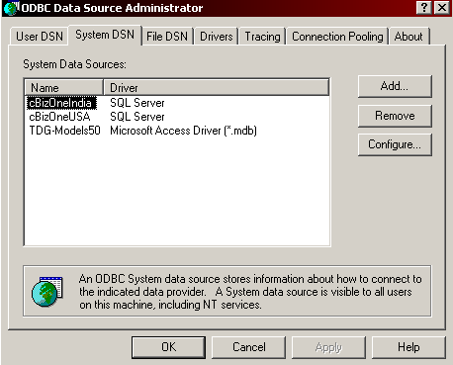

On the computer Click Start, and then Control Panel.

Double-click Administrative Tools. 2. Double-click on Data Sources (ODBC).
A new window will open of ODBC in that choose the tab System DSN

Add System DSN on each machine by clicking on the Add button.

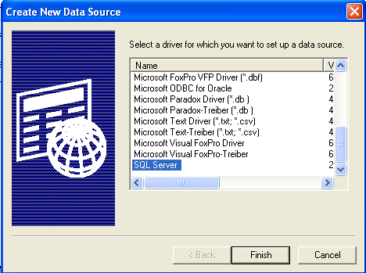

Choose the data source as SQL server, Click Finish

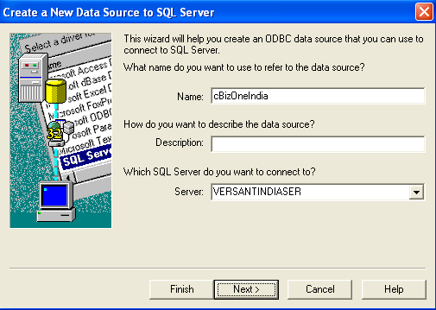
Enter the name as 'cBizOneIndia'(name is optional), Select the name of the SQL server to be connected. (Local or Domain or Hosting) Ex: VERSANTINDSER domain

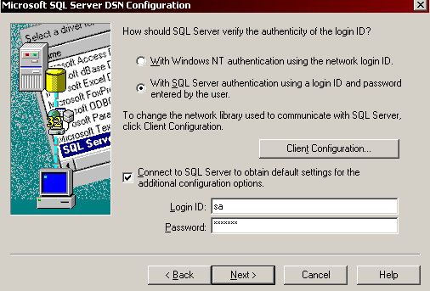

Select SQL Server authentication. Click Client configuration, follow next step and complete to fill Login ID and Password of your SQL server database, and say next.

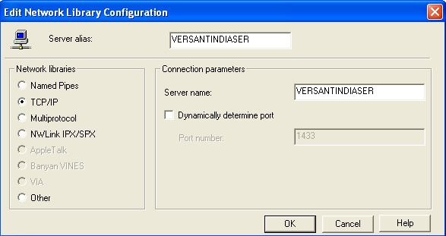

Open the port 1433. (Uncheck Port #)

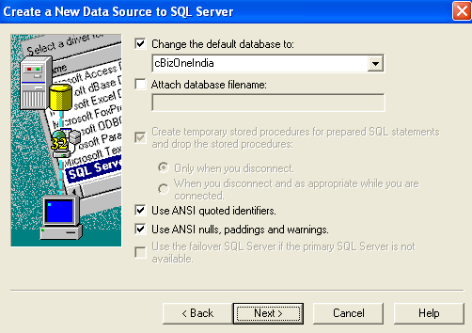

Select the database name (cBizOneIndia) from drop down menu.

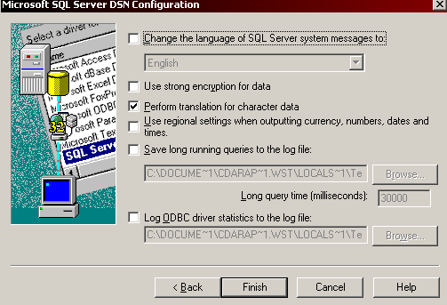

Click finish

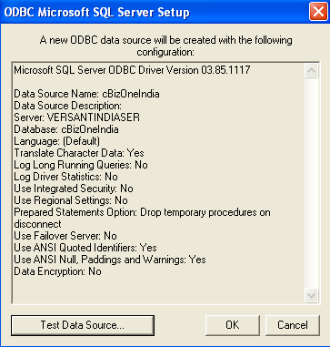

It will prompt a window to Test connectivity between client and server.

Click on the Test Data Source and a confirmation message will display that the tests completed successfully.

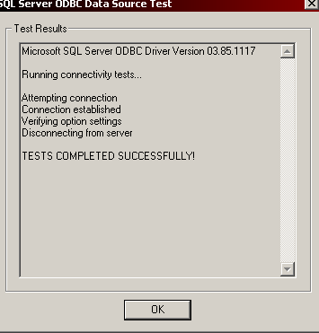

Click Ok

2.5 Configure the DSN

In cBizOneIndia application (Client computer) click on Tools->Options->General, select SQL Server and enter "cBizOneIndia" as the database (DSN)

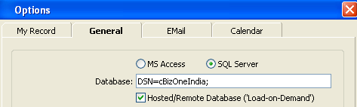

DSN=cBizOneIndia;

2.6 Configuring the cBizOne.

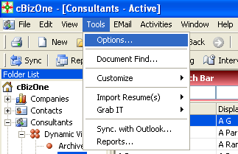

Got o Tools> Options> select it.

At the first time when you run cBizOneIndia application you will have to fill all the tabs shown below, else do it later. The screen shots are shown in the order of tabs. Please follow for the values.
Options:
On the Tools menu, click Options to show the Options window. Options window has the following tabs:
- My Record Tab
- General Tab
- EMail Tab
- Calendar Tab
- Others Tab

2.7 Options in My Record Tab

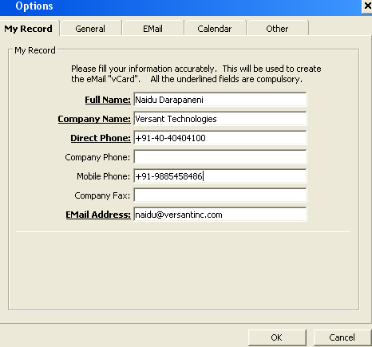

Enter information about you, which will be used to build the 'VCF' card and Signature for outgoing mails.

2.8 Options in General Tab
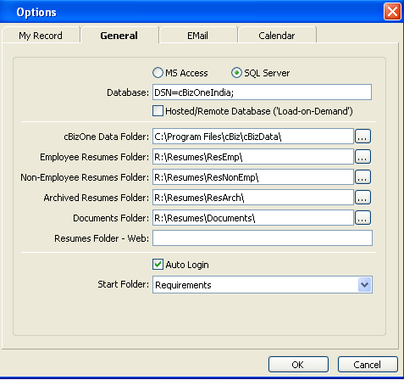
Database Options: You can choose MS Access or SQL Server database option. If you choose MS Access as your Database, it will set cBizOne.mdb as your default database. If you choose SQL Server, you will need to enter a DSN Name in the Database box for which the steps are provided in the 2.4 & 2.5
Hosted/Remote Database: If you are accessing the cBizOne database (SQL Server) remotely, you can check the Hosted/Remote Database box for load-on-demand for optimal remote speed and performance.
- cBizOne Data Folder If you prefer to have one configuration for the entire company with multiple users on your network, you may move cBizDataIndiaV3 folder to a shared network folder and set all users to point to this folder Otherwise, the point to the cBizDataIndiaV3 in cBizOne Installation folder. Copy cBizDataIndiaV3 and paste it in the cBiz installation folder (Ex: c:\Program Files\cBiz). And Point to the cBizDataIndiaV3 Folder.
Ex: C:\Program files\cBiz\cBizDataIndiaV3
Employee Resumes Folder: This is the default folder for the Resumes of candidates who are your employees. You can overwrite this value by pointing to any folder you would like.
Non-Employee Resumes Folder: This is the default folder for the Resumes of Candidates who are NOT your employees. You can overwrite this value by pointing to any folder you would like.
Archived Employee Resumes Folder: This is the default folder for the Resumes of Candidates who are archived (Candidates who do not work for you anymore). You can overwrite this value by pointing to any folder you would like.
Documents Folders: This is the default folder for the Documents attached to any Entity. You can overwrite this value by pointing to any folder you would like.
Resumes Folder - WEB: While composing the 'Candlist', cBizOne automatically inserts WEB Resume Links into the 'Candlist' if you specify the location of resumes on the WEB. This is optional.
Auto Login: By checking Auto Login, cBizOne will automatically open when you launch it. If this box is unchecked, you will need to click login from the launch screen. Originally Un Check the same.
Start Folder: This drop down box allows you to select the folder that will load on default when you open cBizOne. Choose from Companies, Contacts, Candidates, Requirements and Calendar. Make Requirements or Calendar as the Default folder.

2.9 Options in EMail Tab
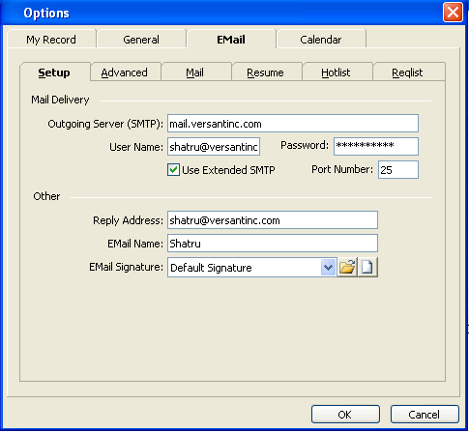
Setup
Outgoing Mail Server (SMTP): Enter the name of your SMTP server.
Username / Password: If your SMTP server requires authentication, enter Username and Password. Normally these will be blank.
Reply Address: You can control where the mail will be 'Replied-To', if the receiver of your mail 'Hits' the 'Reply' button.

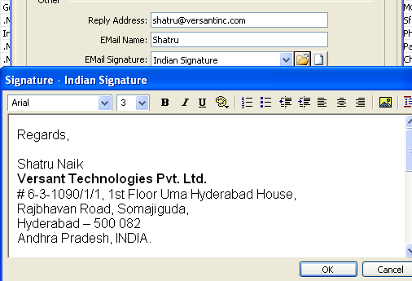
Your EMail Name: Enter your EMail Identity, for example: "Kris, cBizSoft"
EMail Signature: This is the default signature for all mail types (Plain Mail, Candlist Mail, Resume Mail and Reqlist Mail). You can create and assign the default signature for each type of mail.

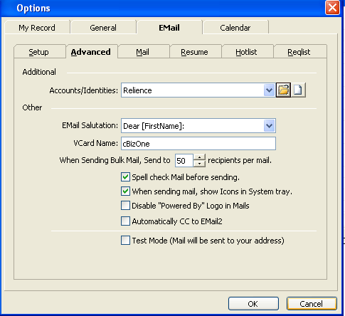

Advanced

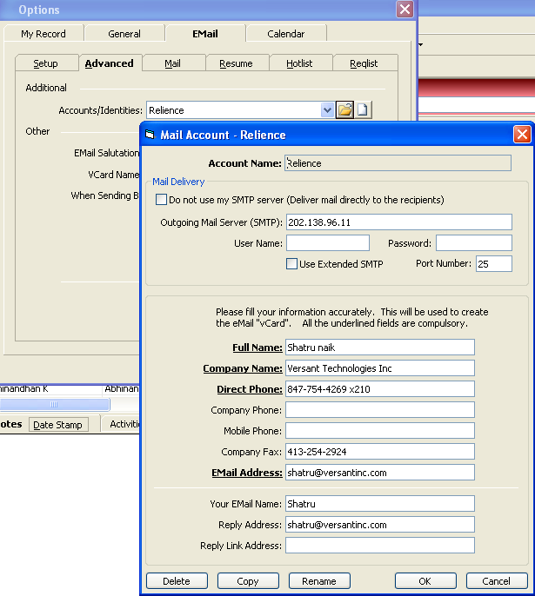

Accounts/Identities: You can create new or modify existing accounts.

Default Salutation for Email: When sending personalized mail, you can customize the salutation for addressing your Contacts and Candidates.
VCard Name: The name entered here will be used as the attachment name when sending a VCard.
When Sending Bulk Mail...: When sending 'Bulk Mail' to your contacts, you can control how many contacts will be in the BCC for each mail.
Spell Check Mail...: Automatically check spelling before sending the mail.
Disable “Powered By” Logo in Mails: By clicking this box, you can remove the “Powered By” logo at the bottom of your sent email.
When sending mail, show Icons in System tray: If checked, it will show email Icons in the system tray when sending emails.
Automatically CC to Email2: By clicking this box, you will not only send email to the primary email address, but also any email address entered in the Email2 field.
Test Mode: This is a very useful feature when you are 'test driving the application'. If you turn the Test Mode On (checked), all the mails you send will be received by you instead of the recipient(s). Please Un Check the Same.
Plain Mail Tab, Resume Mail Tab, Candlist Mail Tab, Reqlist Mail Tab
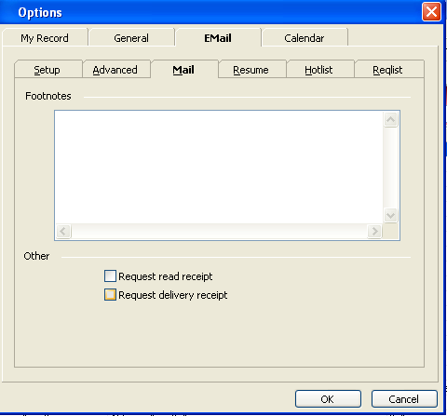
Since there are four kinds of mails in our industry, cBizOne allows you to customize each type of mail. You can set the following defaults for each type of mail.
Footnotes: You can enter any text in this, which will be automatically added at the end of the given type of mail. For example, you may want to enter 'Anti-SPAM Disclaimer' in the Footnotes of the Mail Tab.
The Mail Tab and Resume Mail Tab contain check boxes for Request Read Receipt and Request Delivery Receipt.
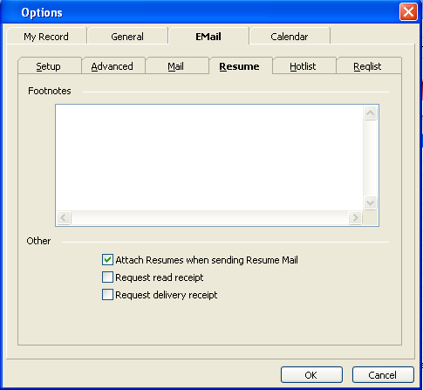
The Resume Mail Tab also contains a check box to automatically Attach Resumes when sending Resume Mail. If checked, you will not have to manually attach a resume when making a submittal.

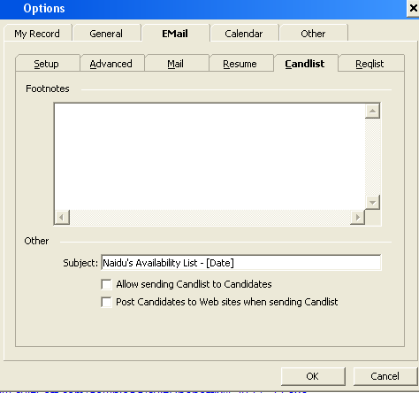

The Candlist Mail Tab includes a Subject box where you can enter a default subject line, which will show in Candlist Email window.
In the Candlist Mail Tab checking Post Candidates to Web sites when sending Candlist, will automatically enable you to post your Candidates to our partner web sites when you send a Candlist Email. Please Un Check the Same.

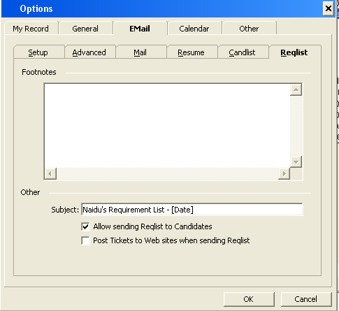
The Reqlist Mail Tab includes a Subject box where you can enter a default subject line, which will show in Reqlist Email window.
In the Reqlist Mail Tab checking Allow sending Reqlist to Candidates, will enable Reqlist choice in Email Menu in the consultant’s folder. Please Check the Same.
In the Reqlist Mail Tab checking Post Requirements to Web sites when sending Reqlist, will automatically enable you to post your Requirements to our partner web sites when you send a Reqlist Email. Please Un Check the Same.

2.10 Options in Calendar Tab
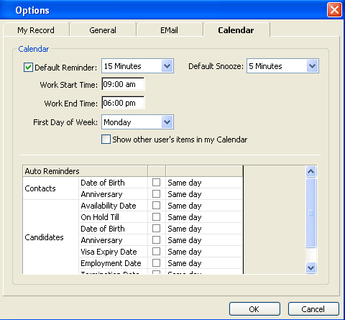
Default Reminder: Turn this on (checked), if you want the application to automatically set a reminder every time you create an appointment.
Work Start Time / Work End Time: Your work starts and end time. Used to shade the non-working hours in the calendar.
First Day of Week: You can customize the calendar to display the first day of week.
Default Snooze: You can set your default snooze time from the drop down menu.
Share Calendar: Check the option of 'Show other user's items in my calendar' to see other user's calendar items.
Auto Reminders: Birthday, Availability, Visa Expiry, And Employment Anniversary, Salary Review etc: You can choose to remind automatically and how many days ahead to remind, for the events of your Contact, Candidates.

2.11 Options in Other Tab

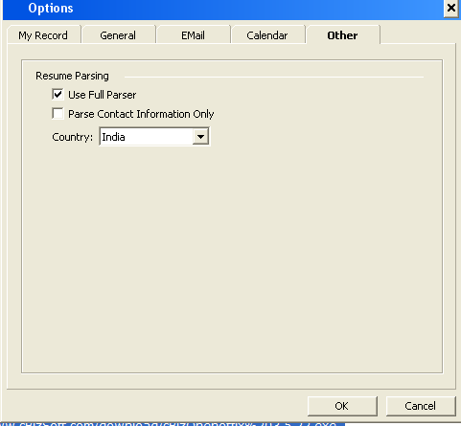

2.12 Open My Database

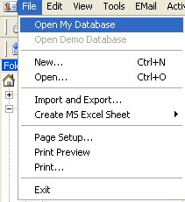

Would automatically close the cBizOneIndia application and re-open it. If you are using SQL Server then first time it would ask SQL Username and Password, please enter those details. If you are MS Access version you should be able to logon directly with Admin username.
3.0 Check Points:

Please follow the following instructions to make sure the cBizOneIndia is properly installed and working properly.
- Create one Company Ex: cBizSoftIndia www.cbizsoftindia.com
- Create one Contact and link the contact to the company Ex: Support support@cbizsoftindia.com +91-40-40404060 X 12
- Attach One Document to company Ex: cBizOneIndia3.5.22Instructions.pdf
- Send one test mail to support@cbizsoftindia.com to verify that mails are going out.
- Parse one resume using import resume option and it should be successfully should be added to the database.
- Make sure you have cBizBar shown in Outlook 2000/2003/2007
- Link One E-mail to the Contact so that we can verify whether cBizBar in Outlook is working properly.

4.0 Support Info:
If any issues please send an e-mail to support@cbizsoftindia.com with screenshot of the error. Below is the contact info. For more information visit www.cbizsoftindia.com

E-Mail:  Sales : Sales@cbizsoftindia.com  Support : Support@cbizsoftindia.com  Billing : Billing@cbizsoftindia.com  Phone:  Support : +91-40-40404060 (Option 12)  Sales : +91-40-40404060 (Option 13) |  |  | Address:  2nd Floor, 3 Cube Towers,  Whitefield Road, Kondapur,  Hyderabad - 500 084  Andhra Pradesh, INDIA

